**Department of Electrical Engineering and   
Computer Science**

**Faculty Member:** Dr. Huma Ghafoor  **Dated:** 9/03/2023

**Semester:** 6th **Section:** BEE 12C

**EE-351 Communication Systems**

Lab 6: Mixer, IF Filter and Envelope Detector

Group Members

| **Name** | **Reg. No** | **Viva / Quiz / Lab Performance** | **Teamwork** | **Ethics** | **Software Tool Usage** | **Analysis of data in Lab Report** |
| --- | --- | --- | --- | --- | --- | --- |
|  |  | **5 Marks** | **5 Marks** | **5 Marks** | **5 Marks** | **5 Marks** |
| Muhammad Ali Farooq | 331878 |  |  |  |  |  |
| Danial Ahmad | 331388 |  |  |  |  |  |
| Muhammad Umer | 345834 |  |  |  |  |  |
| Tariq Umar | 334943 |  |  |  |  |  |

1. **Table of Contents**

**2****RF Power Amplifier 3**

2.1 Objectives 3

2.2 Introduction 3

2.3 Lab Report Instructions 3

**3****Lab Procedure 4**

3.1 Introduction 4

3.2 Procedure A: Connect an AM Transmitter Circuit 6

3.3 Procedure B: RF Filter: Input Power 7

3.4 Procedure C: RF Filter (Adjust for AM Signal) 7

3.5 Procedure D: RF Power Amplifier (Maximize Gain) 8

3.6 Deliverables 9

**4****Conclusion 10**

# Mixer, IF Filter and Envelope Detector

## Objectives

* When you have completed this exercise, you will be able to explain the operation of the mixer, describe the function of IF filter and describe how the envelope detector converts a 455kHz signal to the message signal. You will use an oscilloscope to make AM signal measurements.

## Introduction

The purpose of this lab report is to explore the properties and characteristics of RF Mixer, IF filter and envelope detector. Overall, the lab report aims to provide a comprehensive understanding of the fundamental concepts and practical applications of RF amplifiers and AM.

## Lab Report Instructions

All questions should be answered precisely to get maximum credit. Lab report must ensure following items:

* Lab objective
* Results (screen shots) duly commented and discussed.
* Conclusion

# Lab Procedure

## Introduction

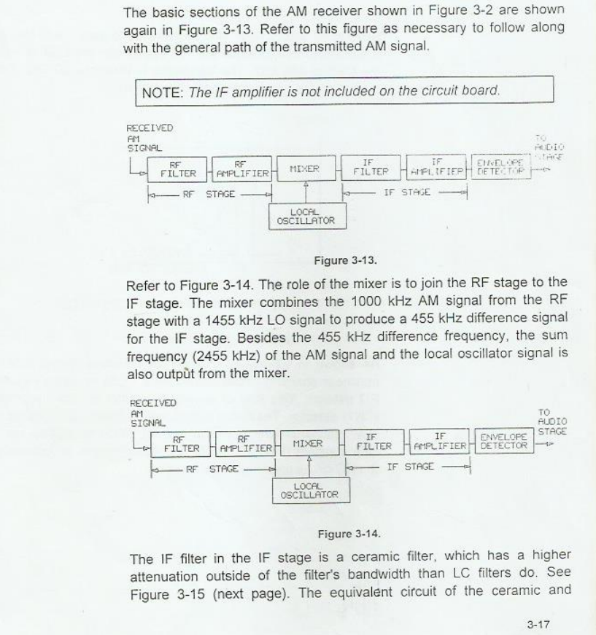

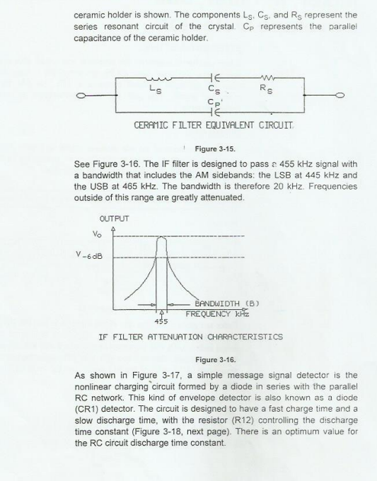

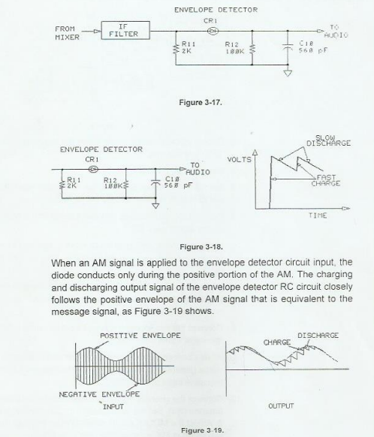

## Procedure A: Connect the AM Transmitter and Set the RF stage

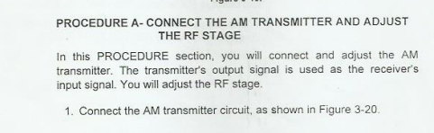

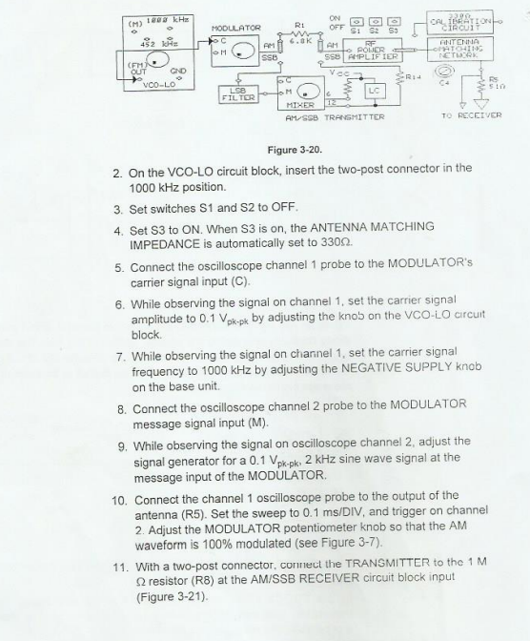

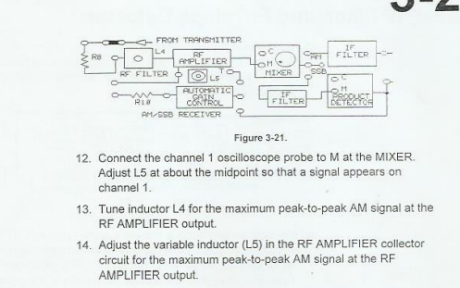

## Procedure B: Mixer

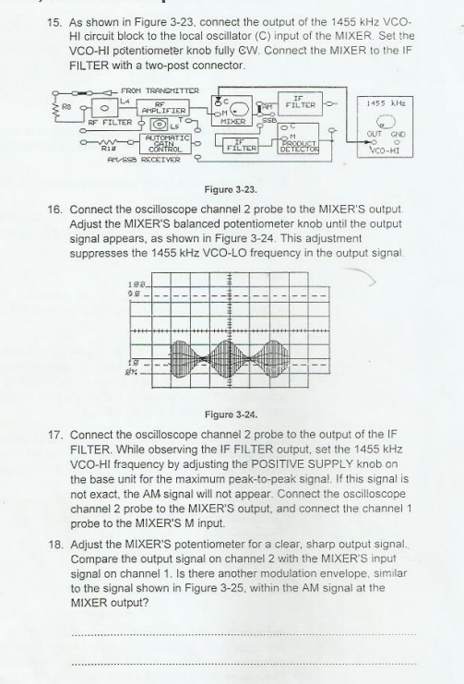

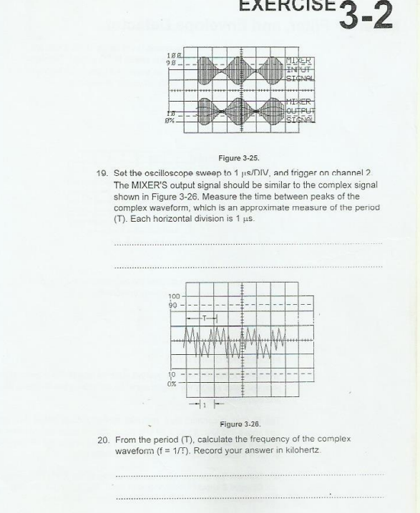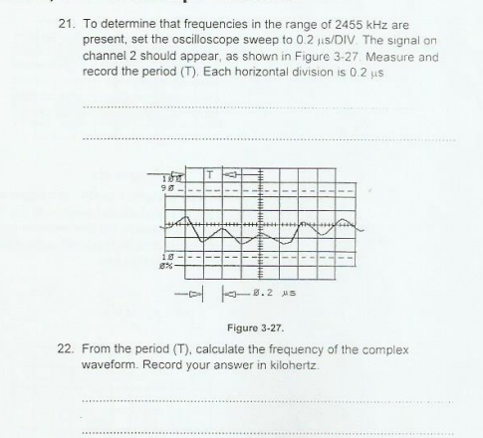

## Procedure C: IF Filter

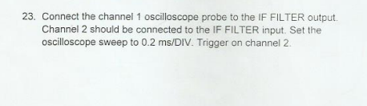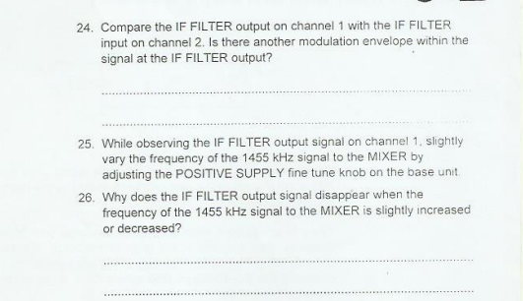

## Procedure D: Envelope Detector:

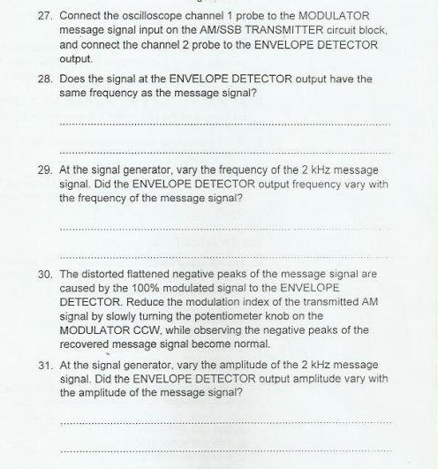

## Deliverables

* **Step 9**

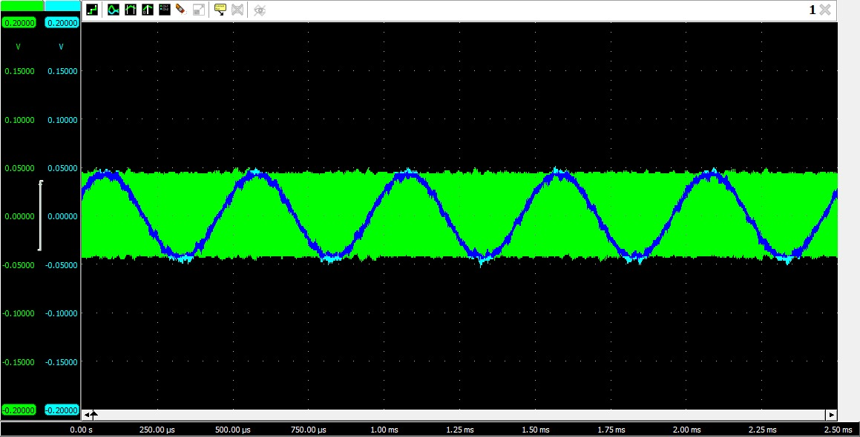

Figure 1: Message (M) and Carrier Signal (C) at MODULATOR Input

* **Step 11**

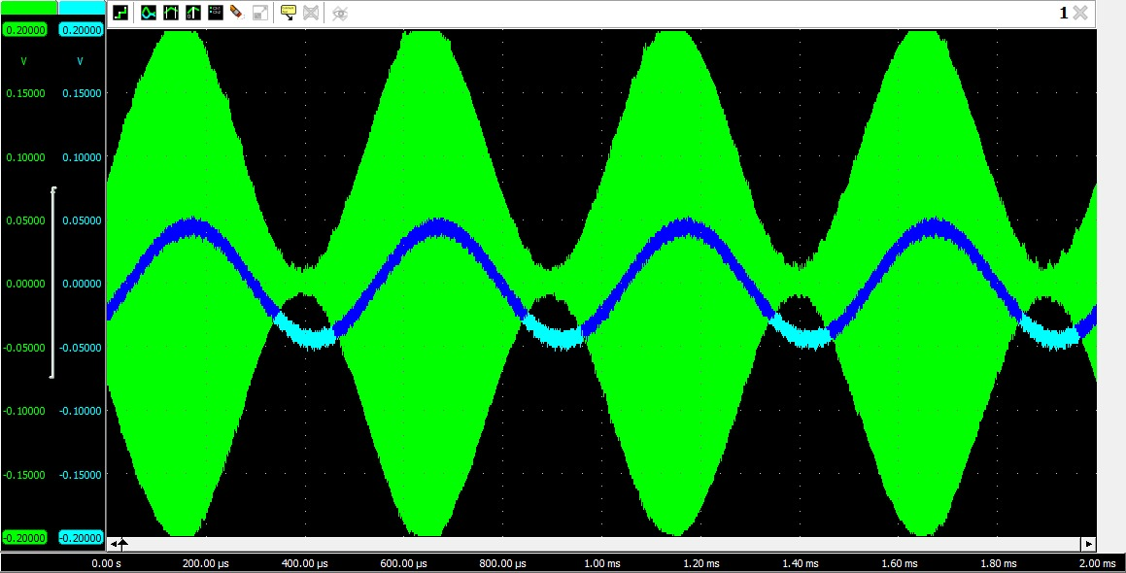

Figure 2: 100% Modulation of message signal

* **Step 17**

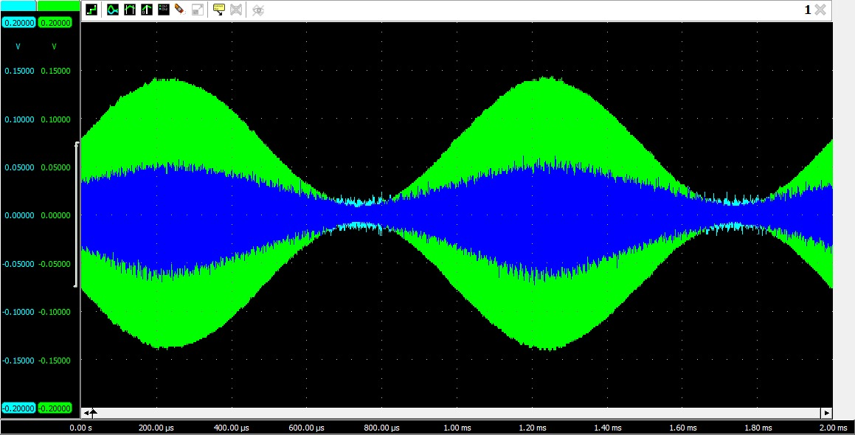

Figure 3: VCO-HI and AM signal

* **Step 18**

Yes

* **Step 19**

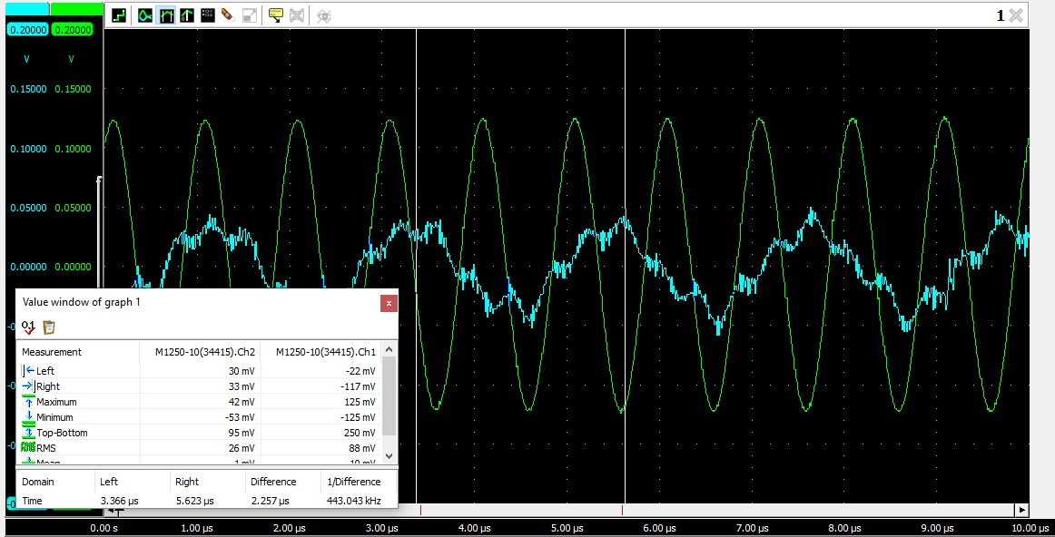

Figure 4

2.25us

* **Step 20**

444.44kHz

* **Step 21**

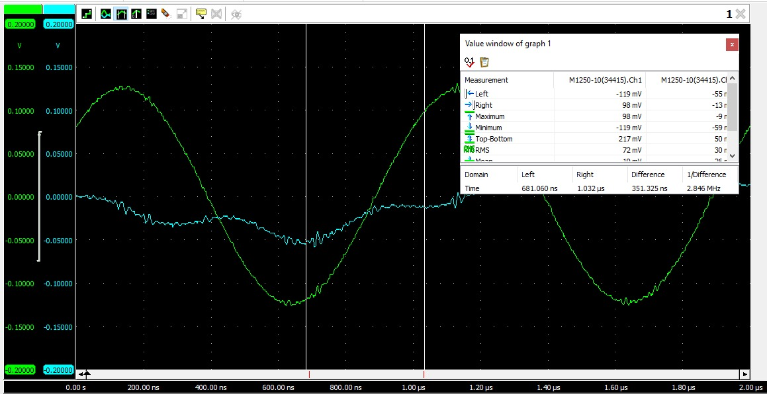

Figure 5

351ns

* **Step 22**

1/352ns

* **Step 24**



Figure 6

No

* **Step 25**

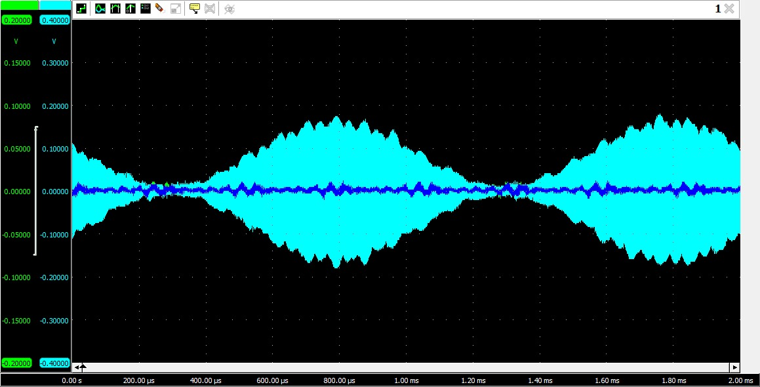

Figure 7

* **Step 28**

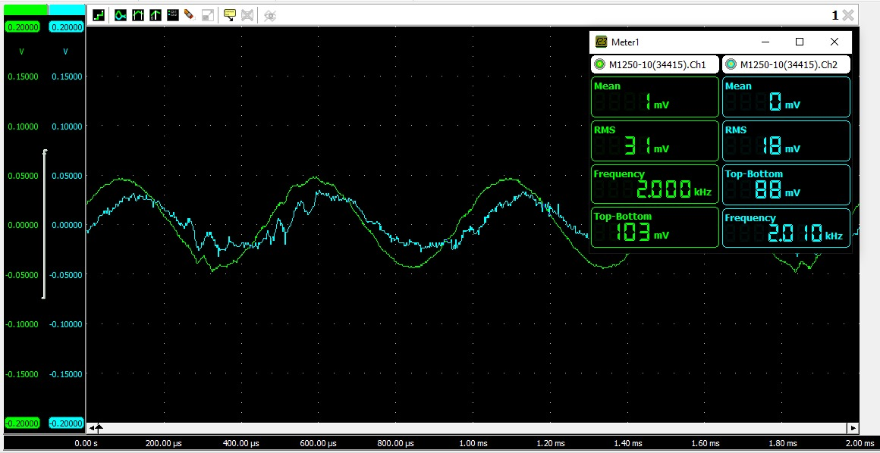

Figure 8

* **Step 29**

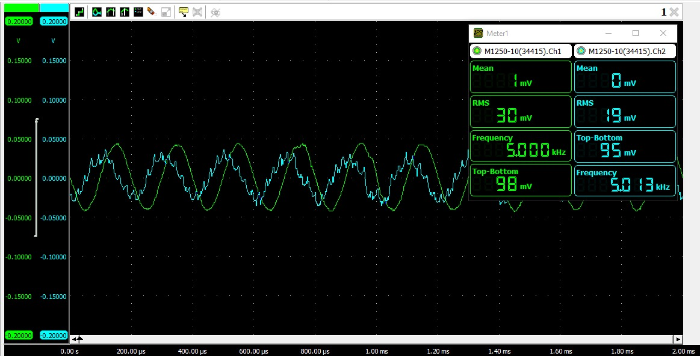

Figure 9

Yes

# Conclusion

We completed the Communication Systems Lab exercise and gained practical knowledge and hands-on experience in understanding the fundamentals of communication systems. By the end of this lab, we had a better understanding of the mixer, IF filter, and envelope detector, as well as their individual functions in the context of modulation in a communication system.